**CMPE 235 – Mobile based Software System Design**

**FALL 2017**



**Lab Assignment 2**

**Submitted by- Submitted to-**

Anvit Saxena Dr. Jerry Gao

SJSU ID: 010953436

1. All the basic steps and MainActivity.java class is covered in Lab 1 of this assignment. This document just covers new features and screen captures of Lab 2 assignment.
2. Below screenshot shows the Application with all the icons:

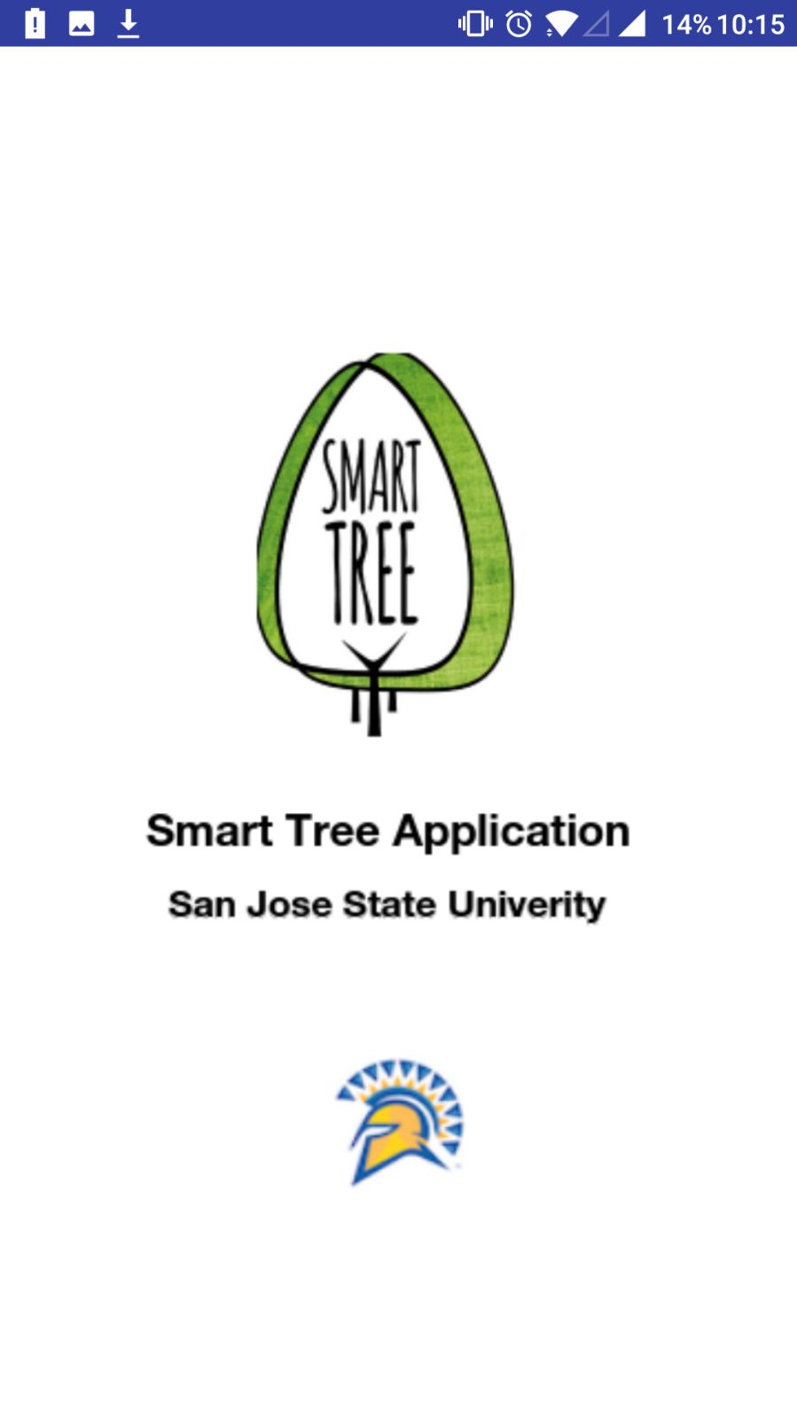

**Welcome Splash Screen**

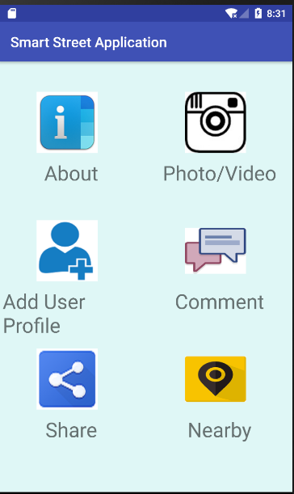

**Main Menu**

1. For requirement 1 ***“Adding three major features: Photo/Video, Share and Audio”*** of this assignment, below screenshot shows my three java activity classes that displays all the icons.

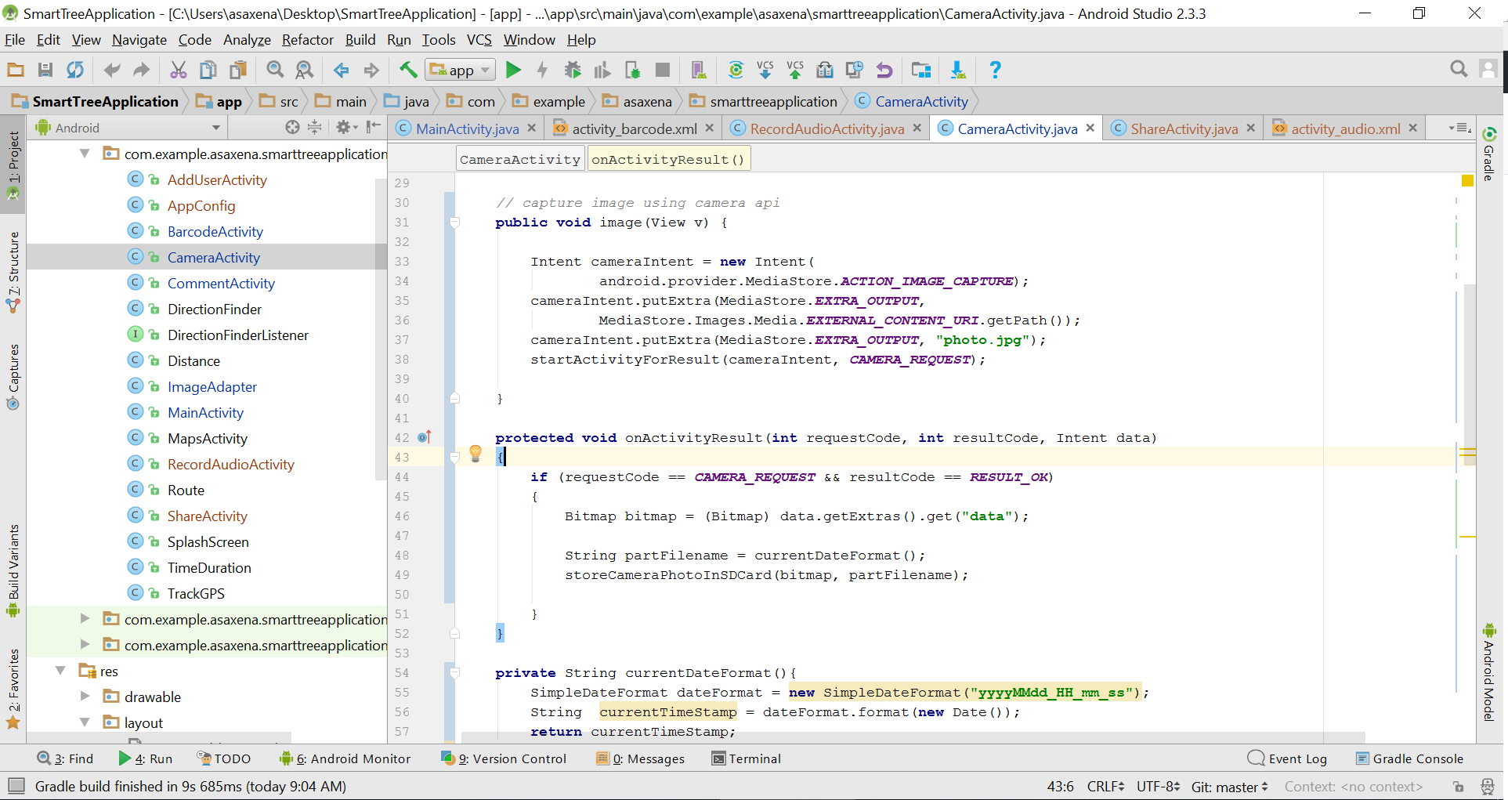

**CameraActivity.java class that handles Photo/Video capture functionality.**

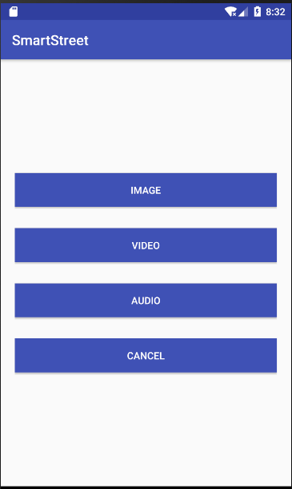

When image button is clicked, camera opens and you have option to click the pic. In this below screenshot, camera is weird since it’s an emulator screenshot.

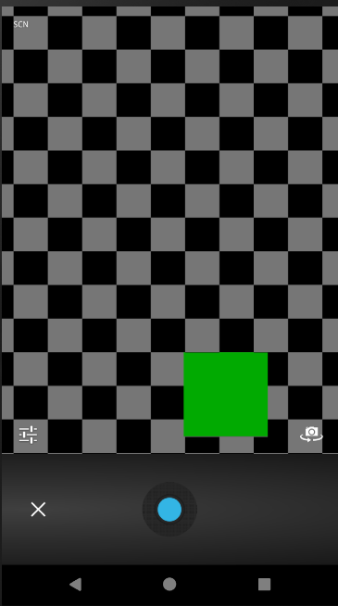

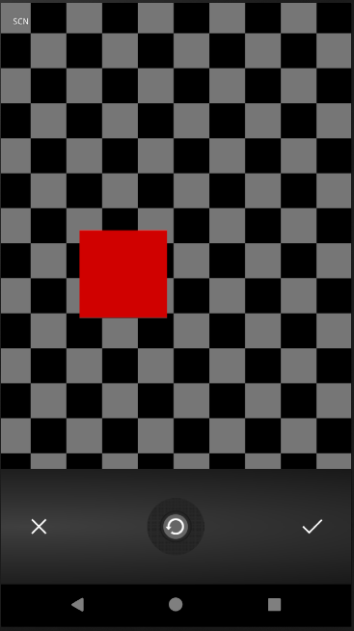

**The above screenshots are for Image capture functionality.**

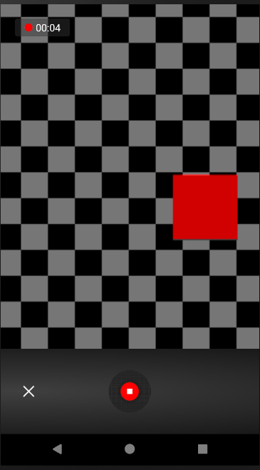



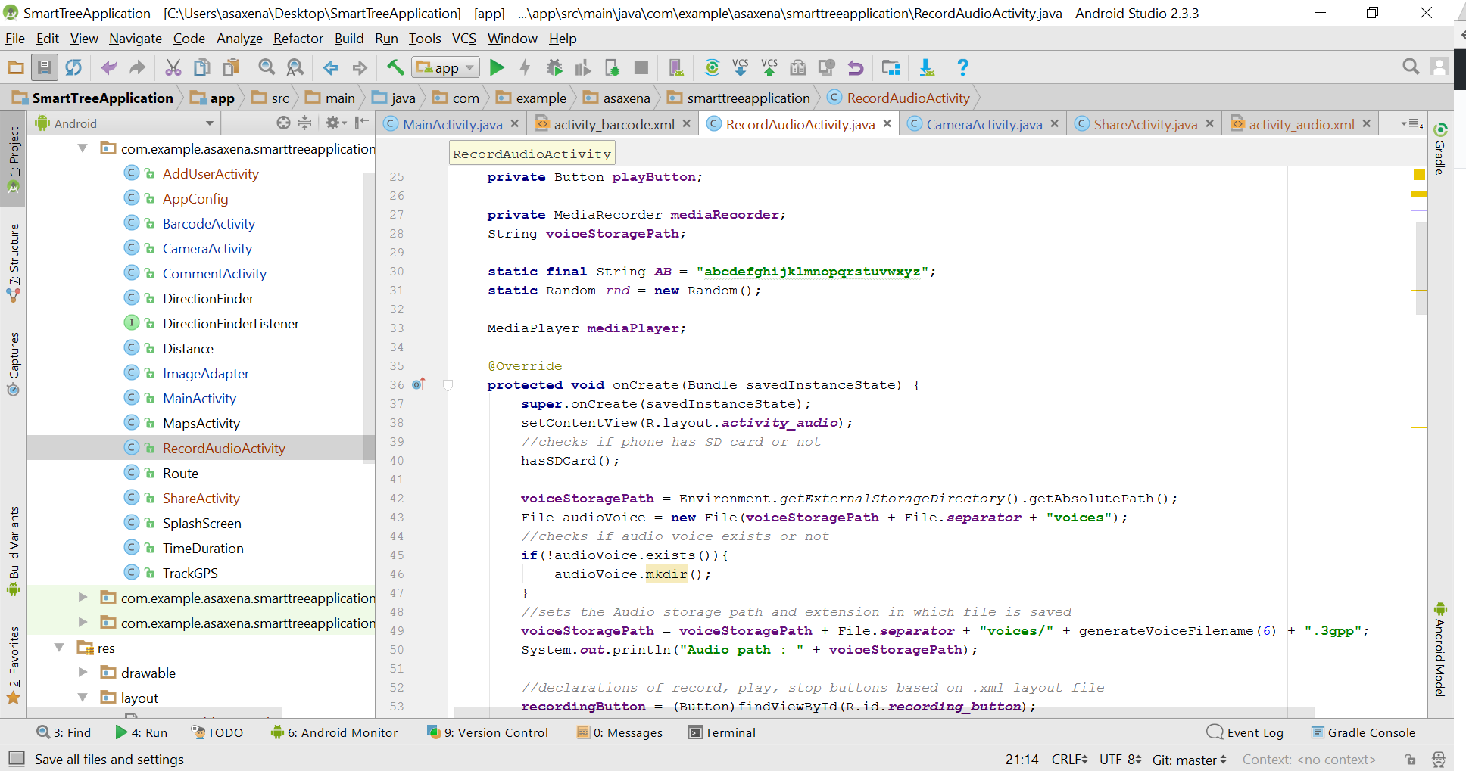

**RecordAudioActivity.java class that handles the audio recording**

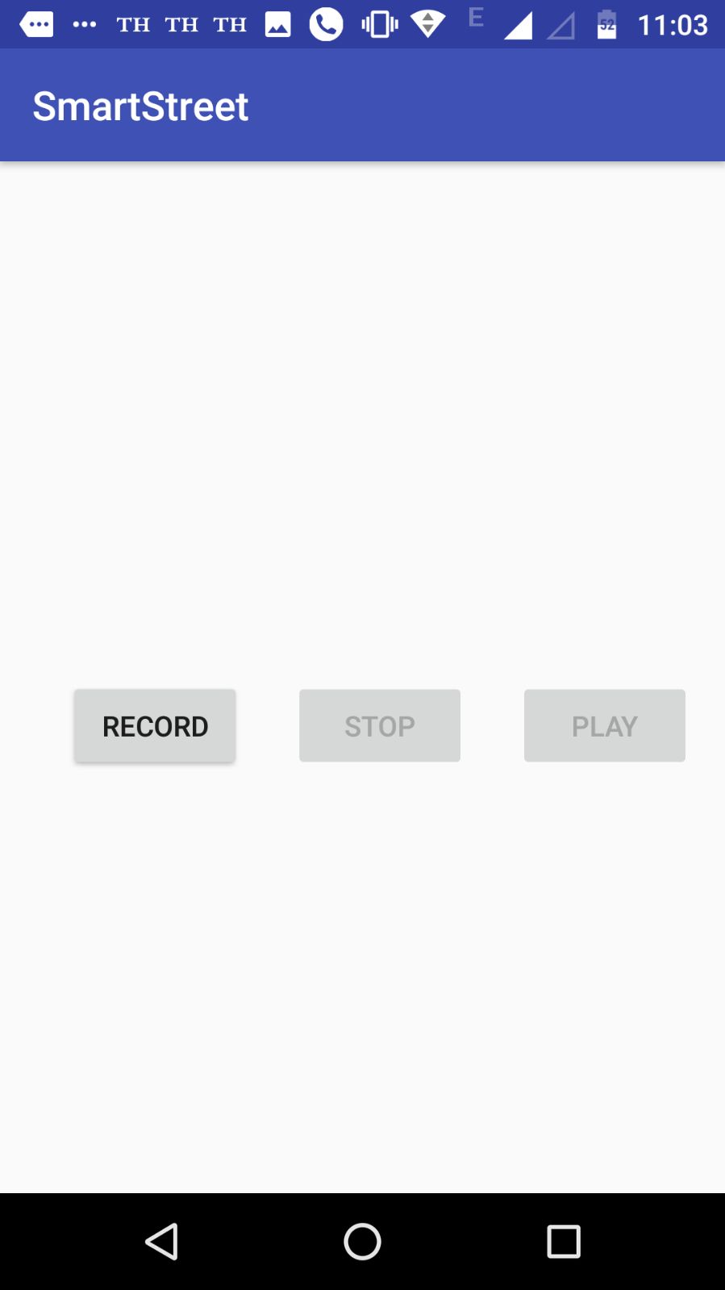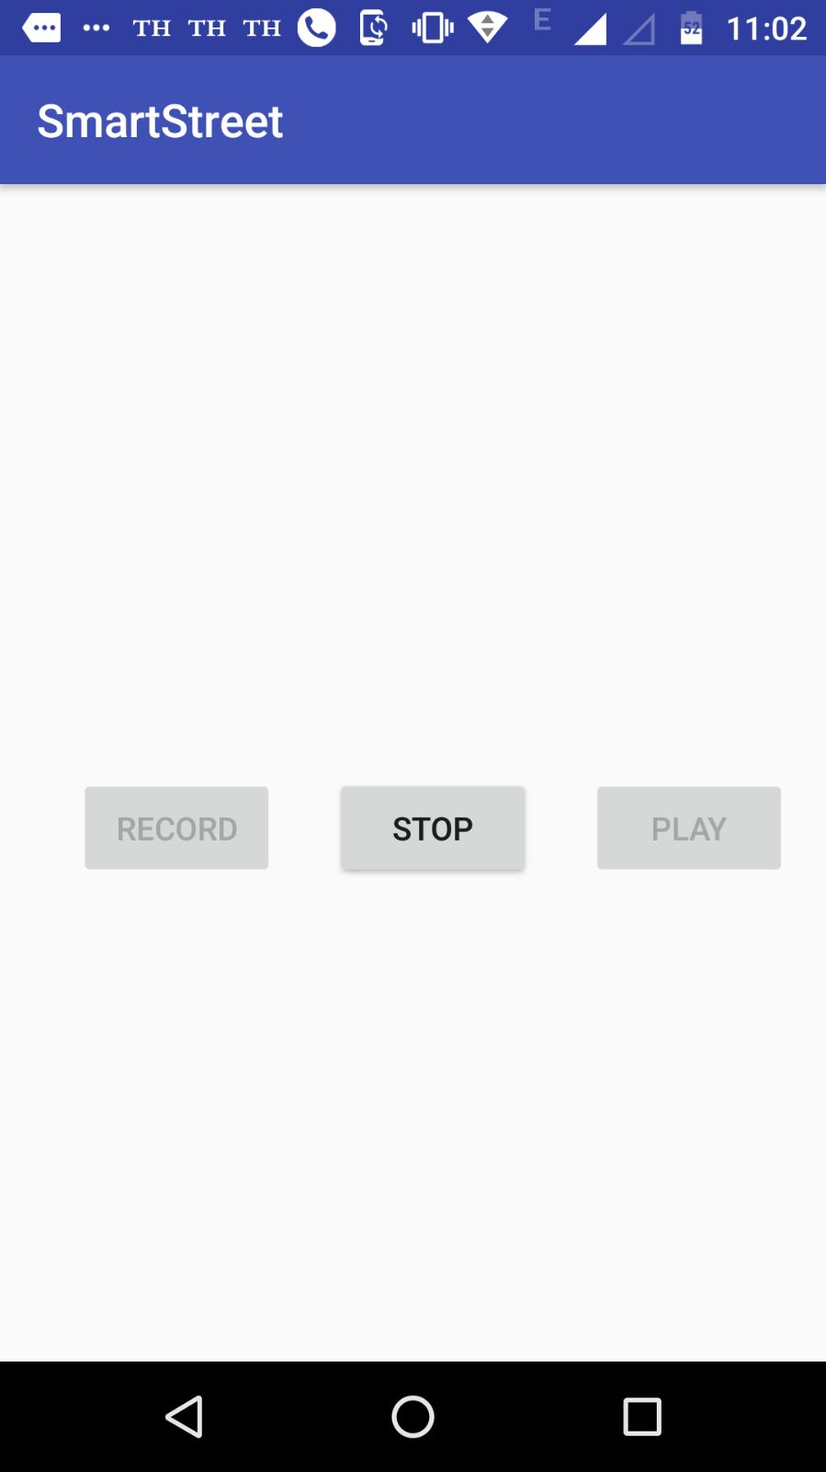

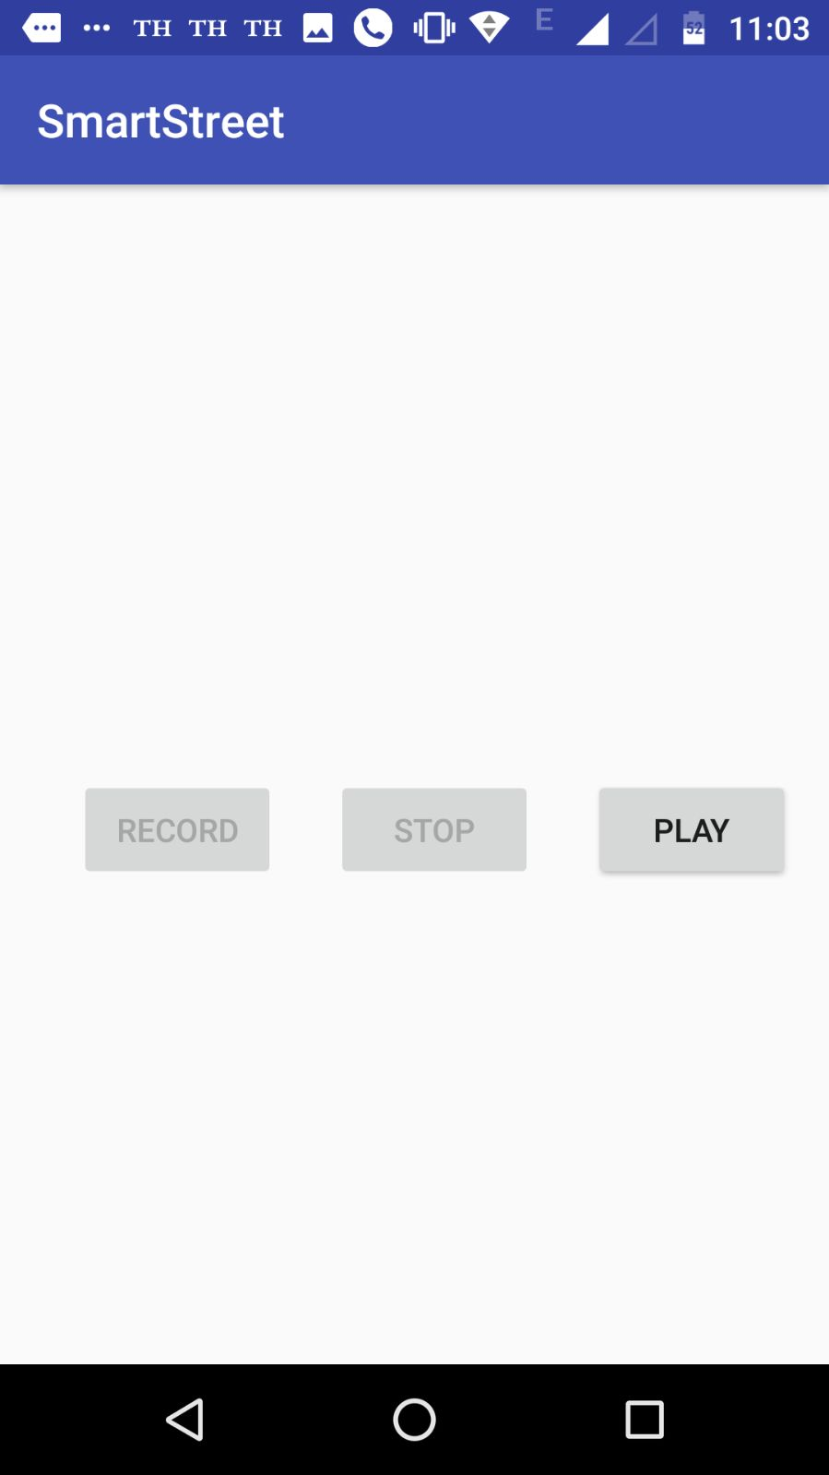

The three buttons are used to record, stop and play activities within the RecordActivity.java class.

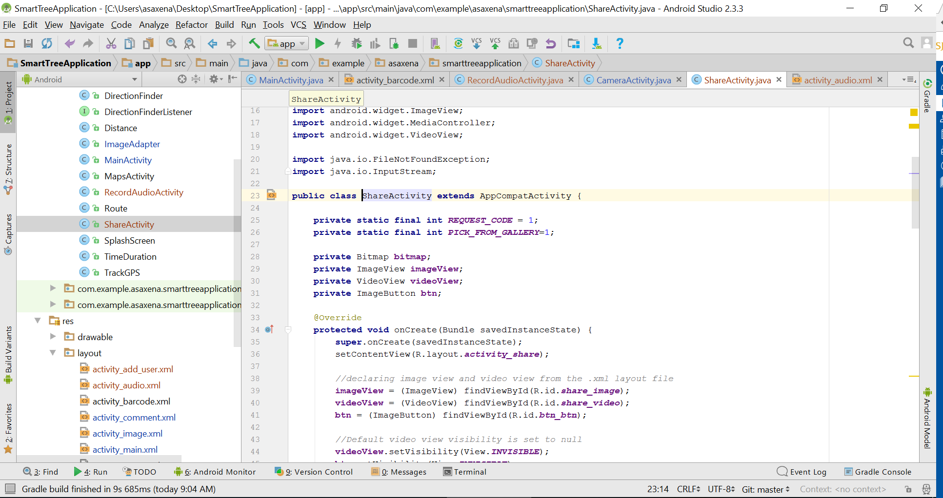

**ShareActivity.java class handles the share features enabled in this application.**

Below screenshots shows the share activity within the application:

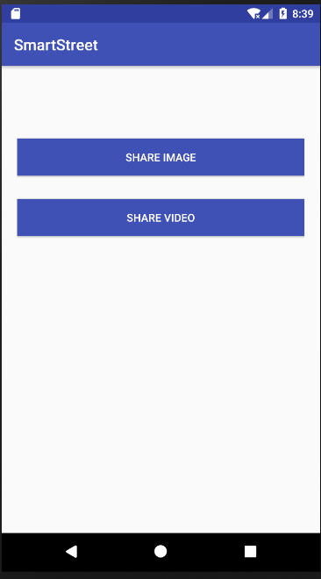

The above two buttons gives user option to share either an image or video.

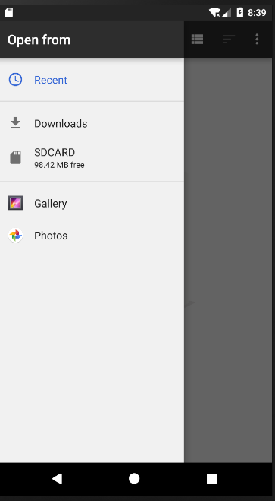

When clicked on video button, the above screen menu comes up with an option to select media source.

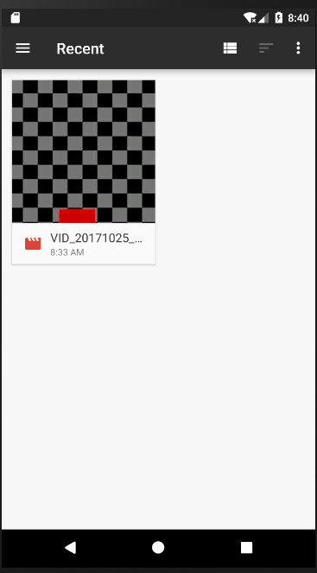

The video that exists in the gallery is selected above and shared using different mediums as shwon in below screenshot. There is also an option to share it using Facebook but since it’s a emulator screenshot, this shows missing. Check demo video link for more details.

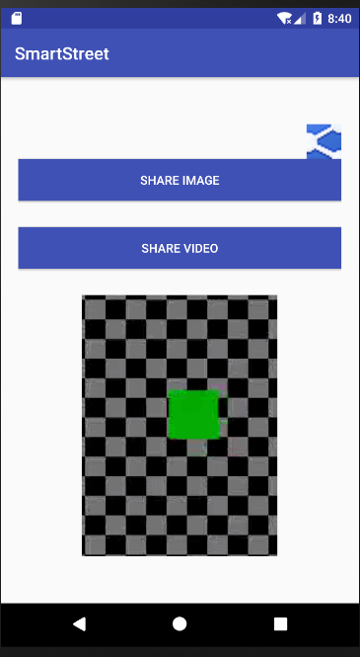

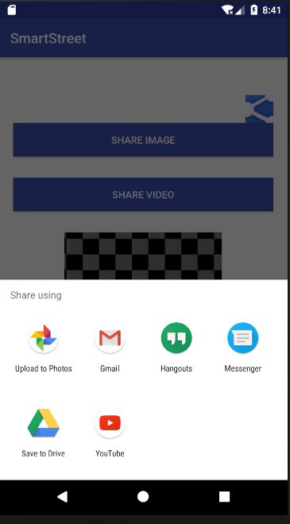

1. For the requirement 2 “***Add mobile user profile function”,*** I have used ZXing barcode scanner API to implement the Barcode and Heroku cloud and mlab database to store the user details upon registration. Below is my java class as well as application screenshot.

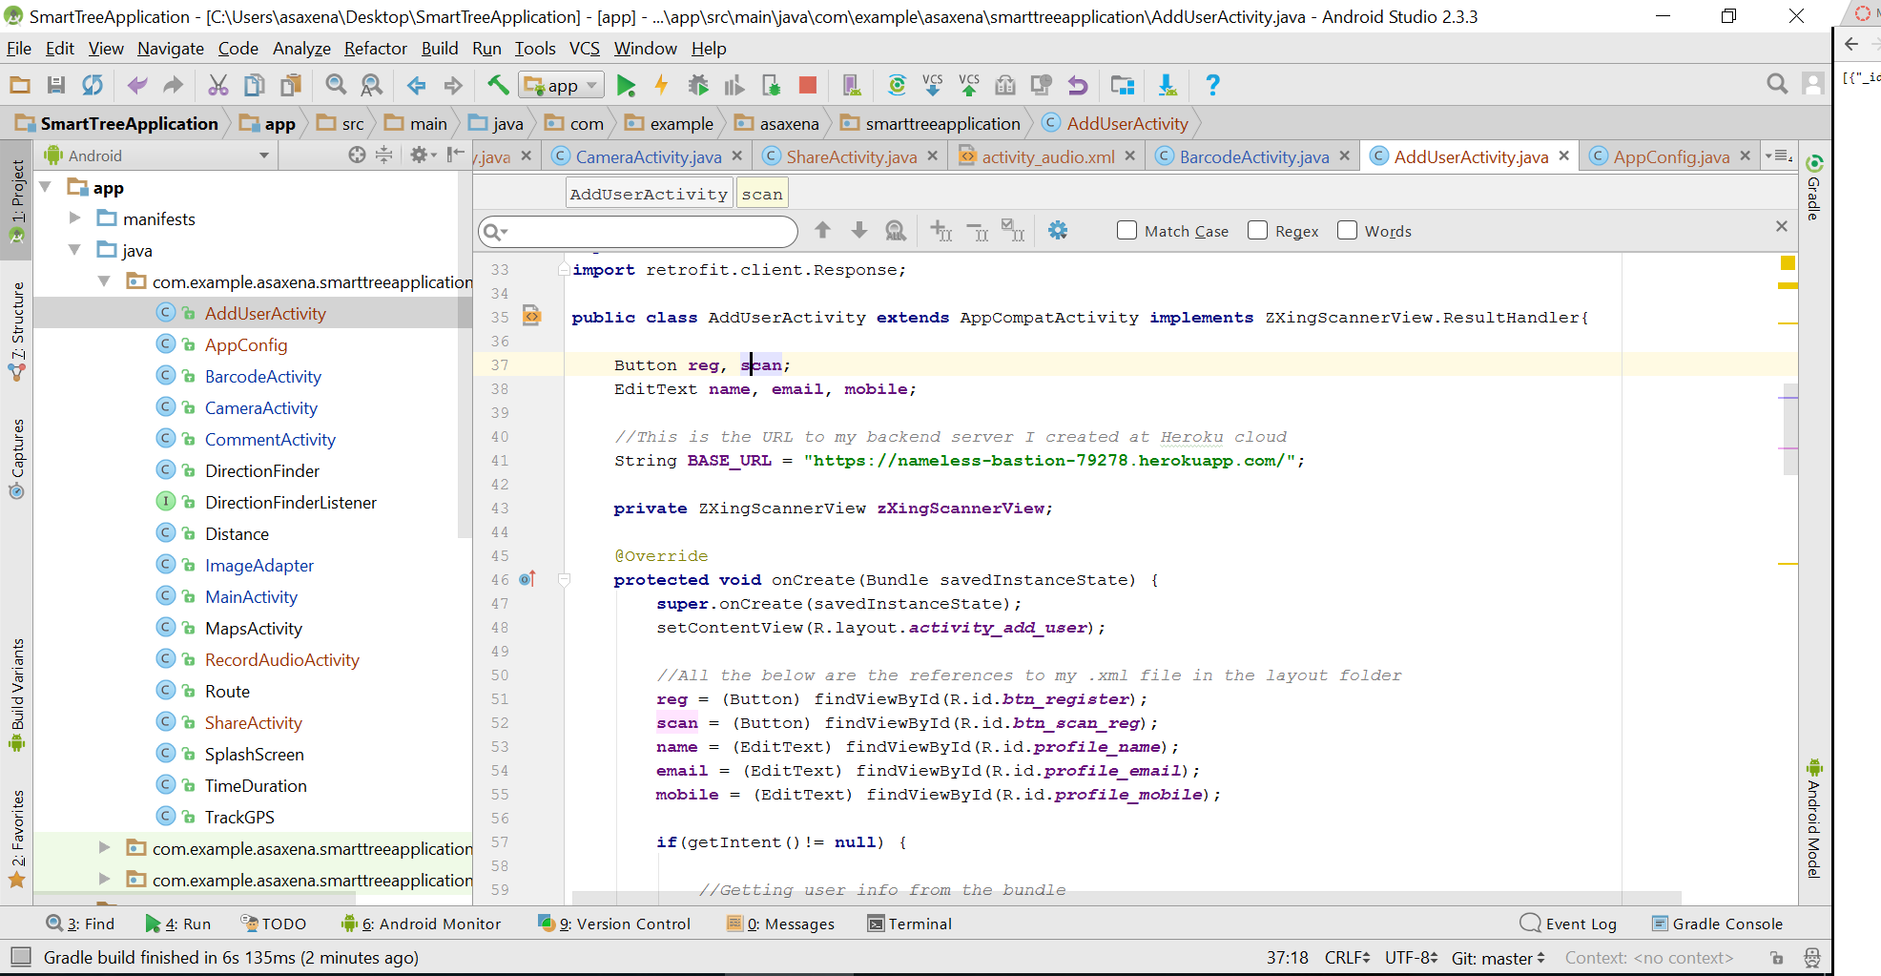

Also, below is the layout representation of the file activity_add_user.xml:

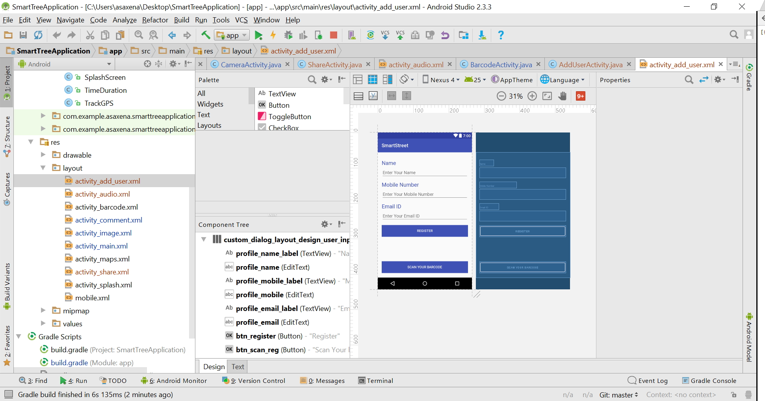

Below are the app screenshots. First screenshot shows the way user enter details in the form and registers for the profile. The button Scan your barcode opens up the barcode scanner and user can register using barcode. Note: This will not be done on emulator and hence I don’t have screenshot available here.

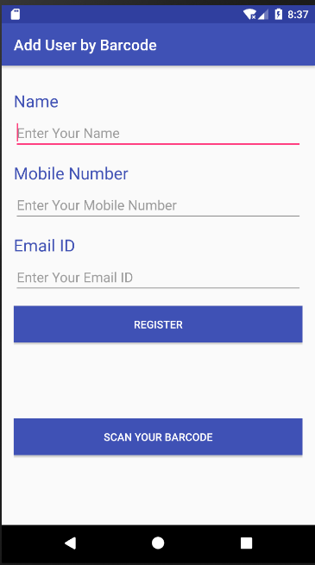

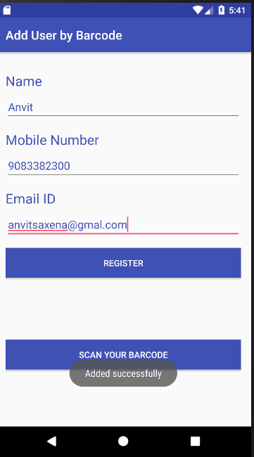

Below screenshot shows the mlab where user details are stored in JSON format as shown below.

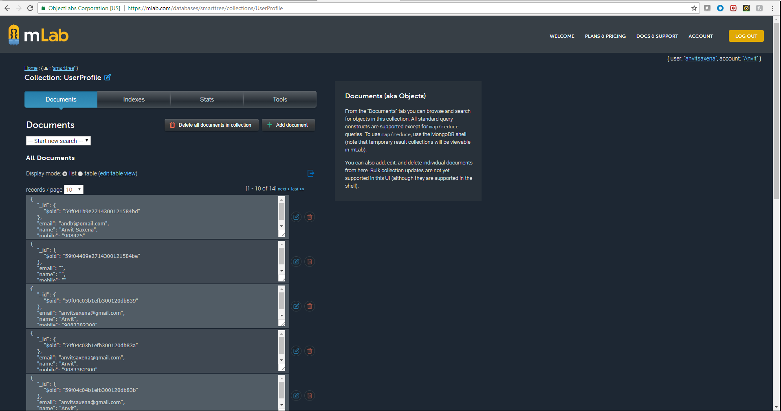

1. For the third requirement “***Allow user to enter their comments about Smart Street”,*** below is the activity java class that shows my imnplementation. I have used Heroku cloud and mlab to store and retrieve user comments. User’s comments can be retrieved using the user name he gave while adding comment.

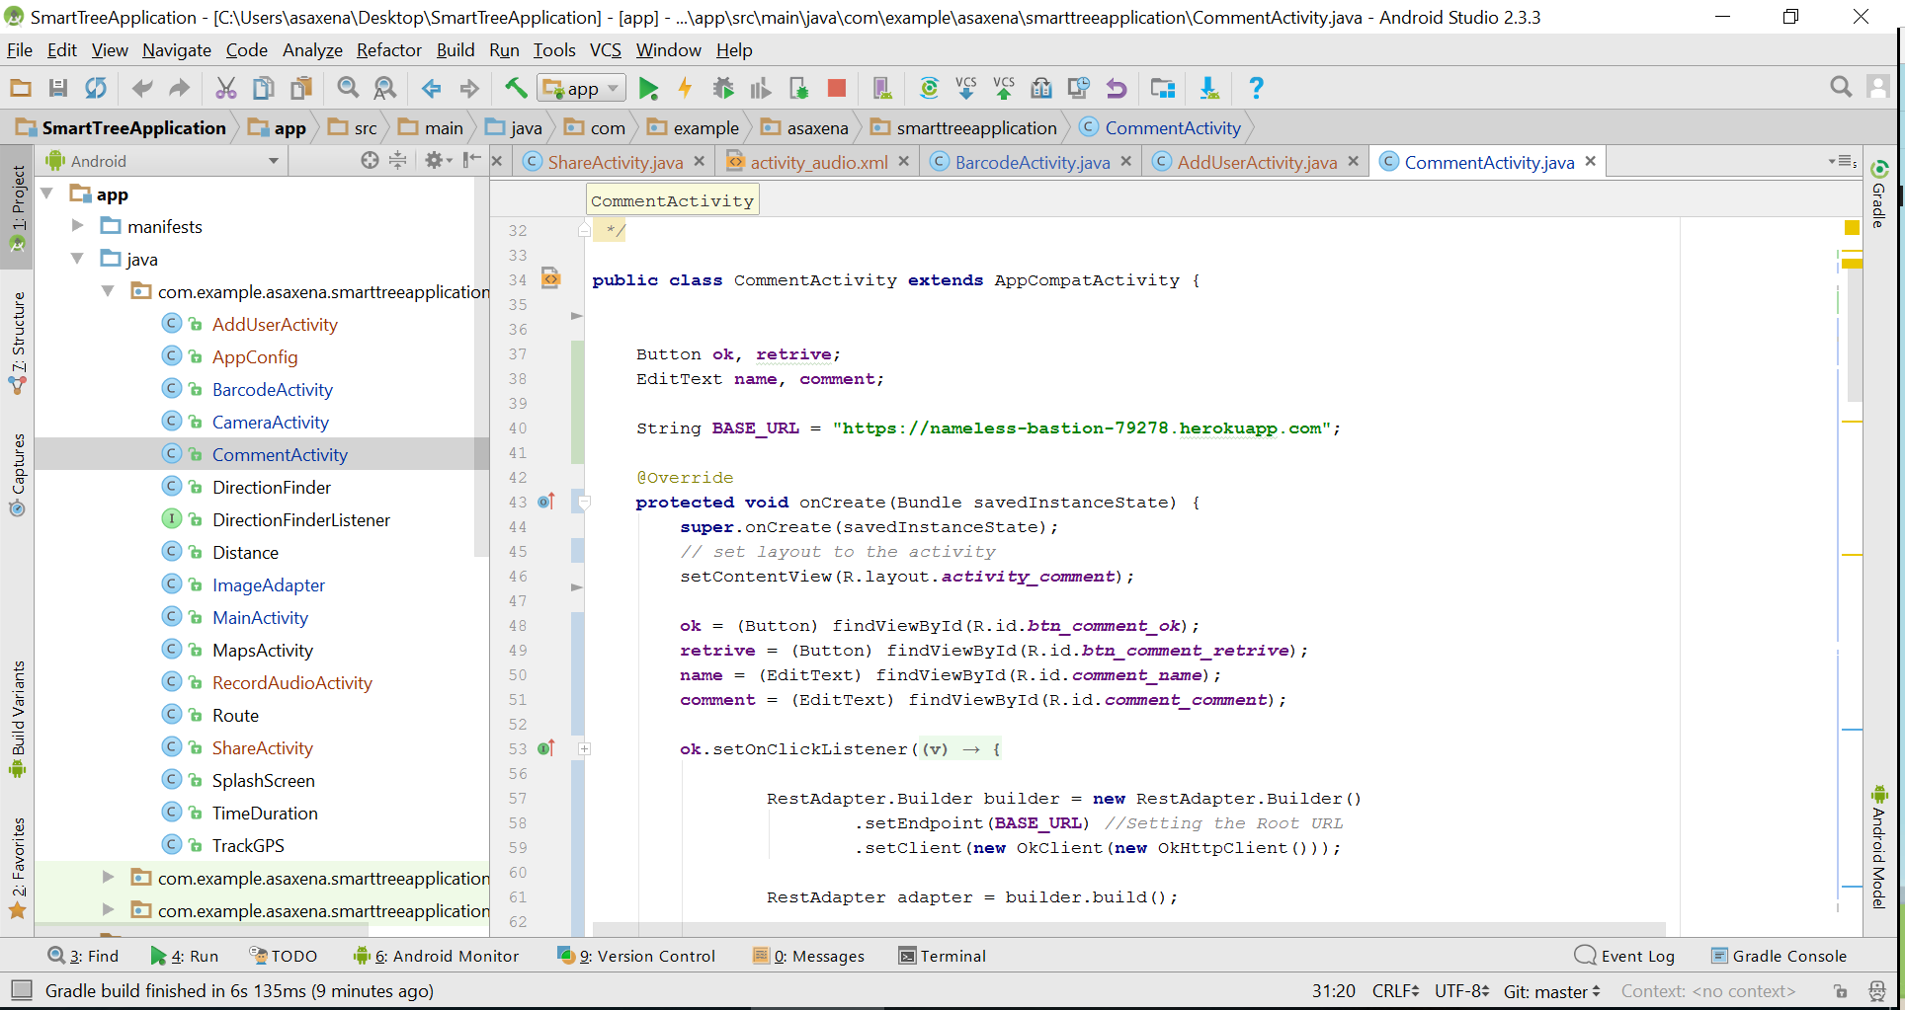

Below screenshot shows the activity_comment.xml layout file:

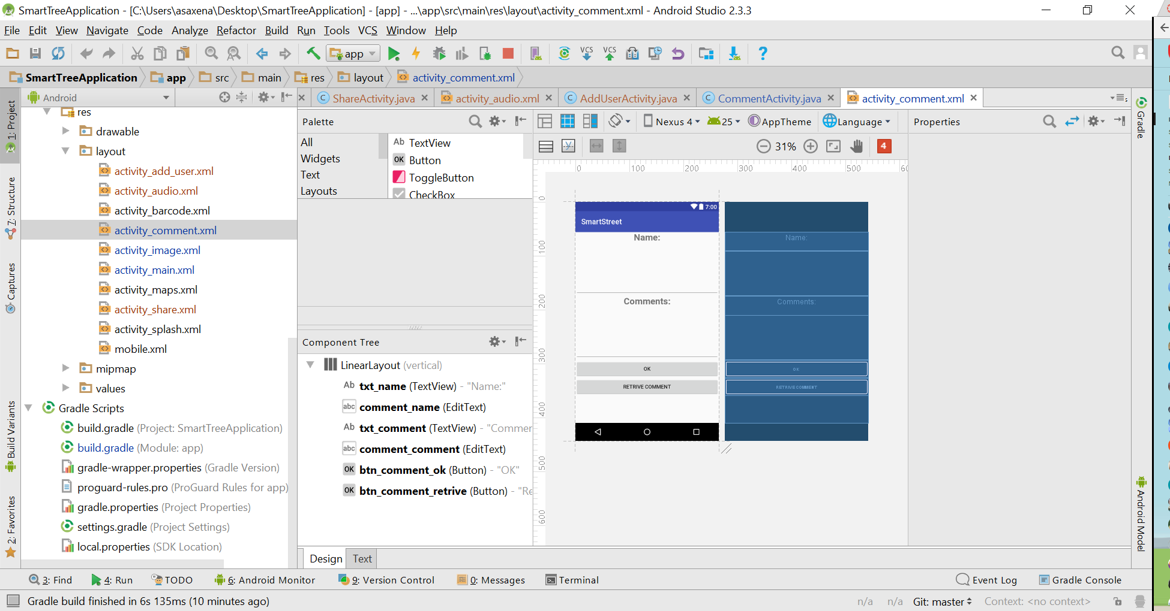

The values once submitted are stored in mlab as shown below:

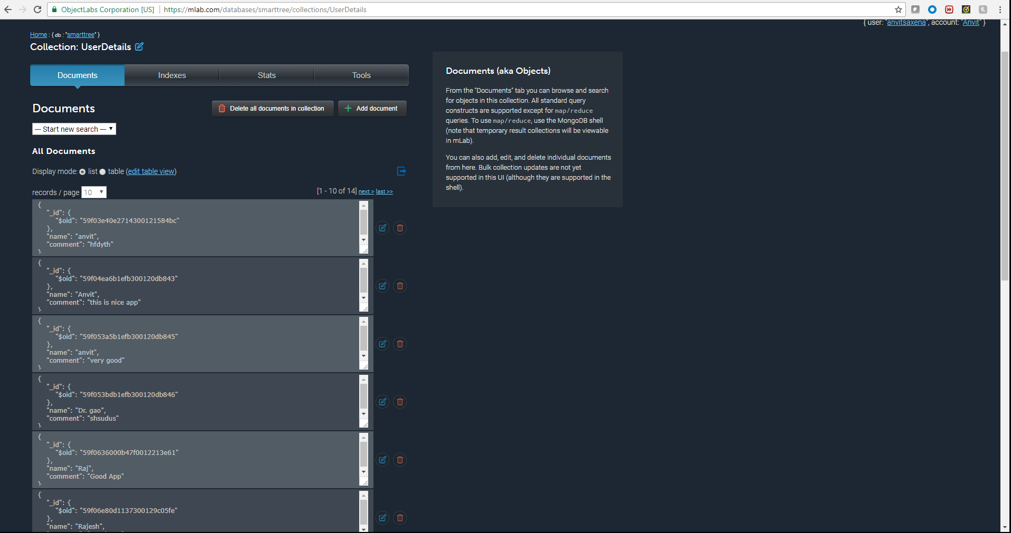

The same JSON data can also be retrieved using direct heroku cloud link followed by mlab collection name as shown below:

[**https://nameless-bastion-79278.herokuapp.com/userlist**](https://nameless-bastion-79278.herokuapp.com/userlist)

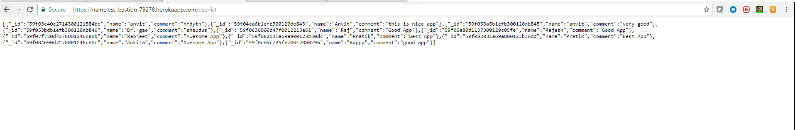

Similarly, for one particular user it can be retrieved by giving username in the end of the link as shown below:

<https://nameless-bastion-79278.herokuapp.com/userlist/anvit>



And now, below are the screenshots of the application:

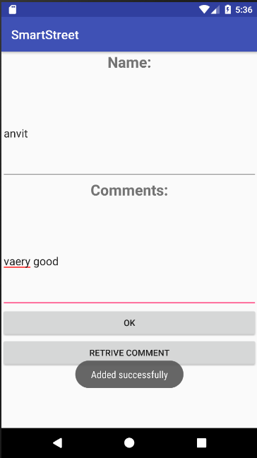

The same comment can be retrieved once the Retrieve comment button is clicked and username is provided in the name box.

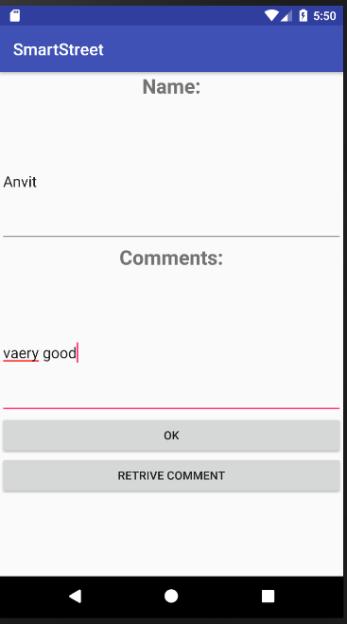

The other components in the application like About, Interact, Nearby stays the same and have been covered in Lab 1 document.

**Lab 2 App Demo Link:** https://drive.google.com/file/d/0BxrlL3Dg3KciSmRtRUxTYWM2SVE/view

**Lab 1 App Demo Link:** <https://youtu.be/oGdWo-i9Oco>

**Github Link for Node Server on Heroku Cloud:** <https://github.com/anvitsaxena/Server-for-Smart-Street>